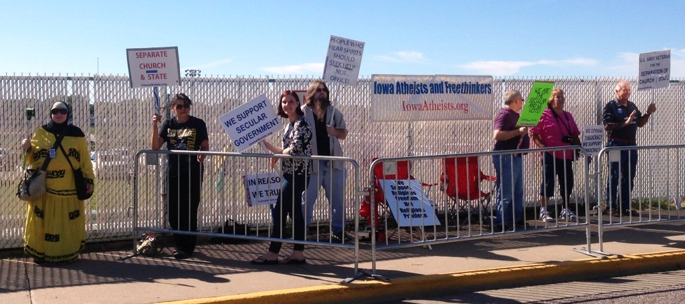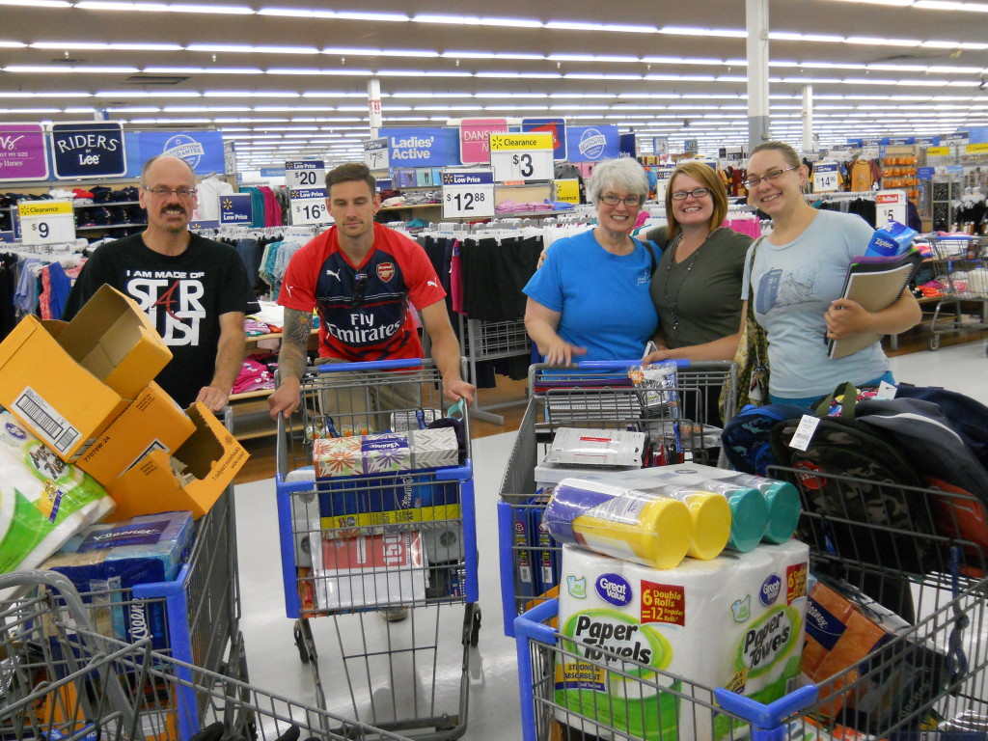
January 2016
Sunday | Monday | Tuesday | Wednesday |  | Thursday | Friday | Saturday
 |  |  |  |  |  | 1  New Year's Day | 2
3 | 4 | 5 | 6 |  | 7 | 8 | 9
10 | 11 | 12 | 13 |  | 14 | 15 | 16 Religious  freedom day  Black non-believers 5th anniversary
17 | 18  ML King Day | 19 | 20 |  | 21 | 22 | 23
24 | 25  Anti-Bullying week | 26 | 27 |  | 28 | 29 Freethinkers  Thomas Paine  day | 30
31

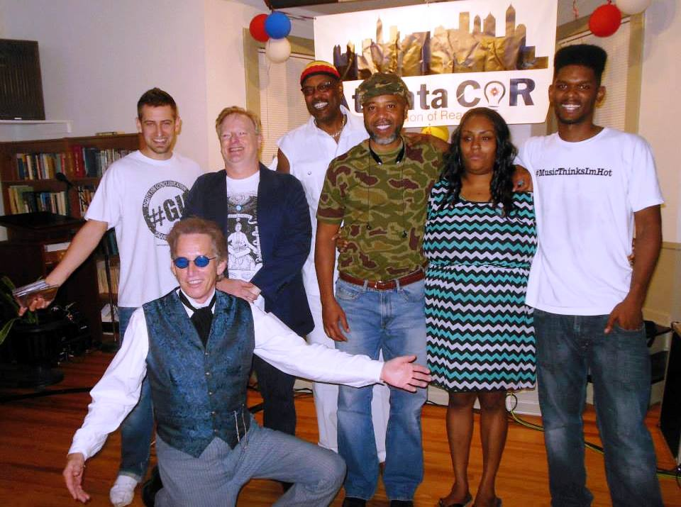
Atlanta CoR

February 2016 |  |  |  | Black History Month
Sunday | Monday | Tuesday | Wednesday |  | Thursday | Friday | Saturday
 | 1  National Freedom Day | 2  Groundhog Day | 3 |  | 4 | 5 | 6
7 | 8 | 9 | 10 |  | 11 | 12  Darwin Day | 13
14  Lincoln B'day | 15  Presidents' Day | 16  Washington B'day | 17 |  | 18 | 19 | 20
21 | 22 | 23 | 24 |  | 25 | 26 | 27
28 | 29

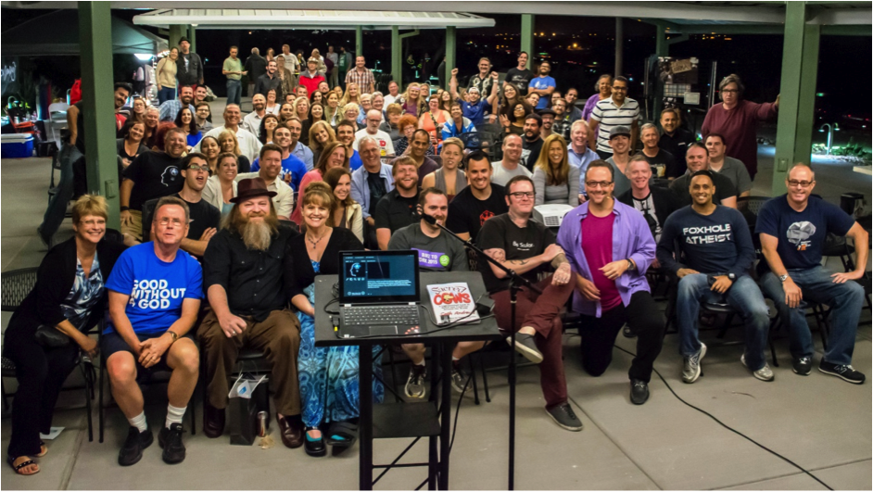
San Diego CoR
March 2016 |  |  |  | National Women's History Month
Sunday | Monday | Tuesday | Wednesday |  | Thursday | Friday | Saturday
 |  | 1 | 2 |  | 3 | 4 | 5
6 | 7 | 8  International Women's day | 9 |  | 10 | 11 | 12
13 | 14  Pi Day | 15 | 16 |  | 17 | 18 | 19
20  International day of Happiness | 21  World Poetry Day | 22 | 23 |  | 24 | 25 | 26
27 | 28 | 29 | 30 |  | 31

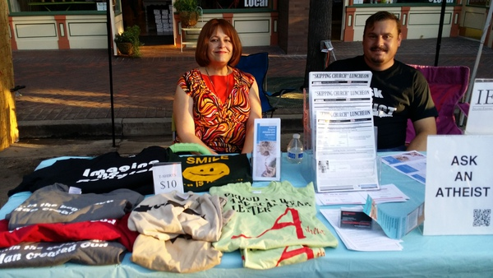
Inland Empire CoR
April 2016
Sunday | Monday | Tuesday | Wednesday |  | Thursday | Friday | Saturday
 |  |  |  |  |  | 1 | 2  CARE conference Hartford CT
3 | 4 | 5 | 6 |  | 7 | 8 | 9
10 | 11 | 12 | 13  Christopher Hitchens day |  | 14 | 15 | 16
17  National ask an Atheist day | 18 | 19 | 20 |  | 21 | 22  Earth Day | 23
24  Day of Silence | 25 | 26 | 27 |  | 28 | 29 | 30

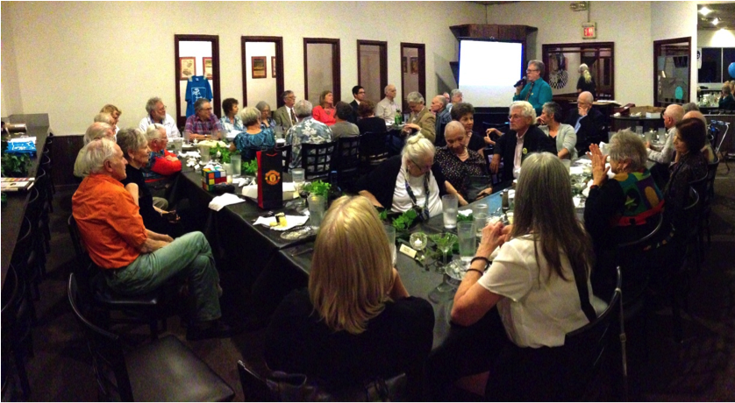
Tallahassee CoR
May 2016
Sunday | Monday | Tuesday | Wednesday |  | Thursday | Friday | Saturday
1  International Workers Day | 2 | 3  World Press Freedom Day | 4 |  | 5  National Day of Reason | 6 | 7
8  Mothers Day | 9 | 10 | 11 |  | 12 | 13 | 14
15 | 16 | 17 | 18 |  | 19 | 20 | 21
22 | 23 | 24 | 25 |  | 26  AHA Conference  26-29 Chicago | 27 | 28
29 | 30  Memorial Day | 31

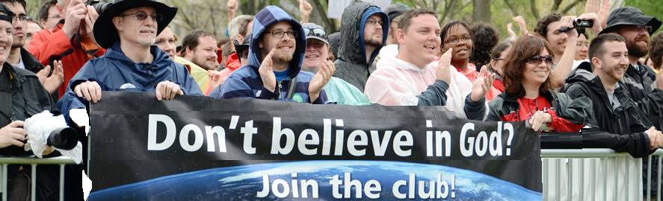
Omaha CoR at Reason Rally
June 2016 |  |  |  | LGBT Pride Month
Sunday | Monday | Tuesday | Wednesday |  | Thursday | Friday | Saturday
 |  |  | 1  SCA Lobby  days 1-2 |  | 2 | 3 | 4  Reason Rally @  Lincoln memorial
5  World Environment Day | 6 | 7 | 8 |  | 9 | 10 | 11
12 | 13 | 14 | 15 |  | 16 | 17 | 18
19  Father's Day | 20  Summer Solstice | 21  World Humanist Day | 22 |  | 23 | 24 | 25
26 | 27 | 28 | 29 |  | 30

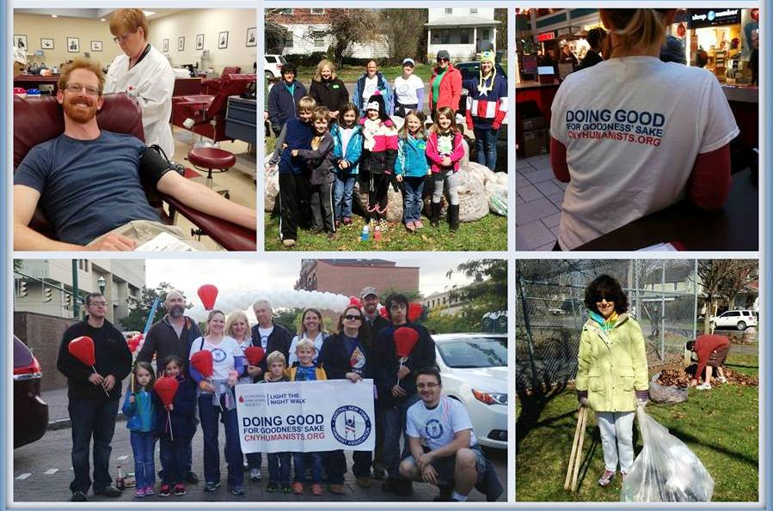
Central New York CoR
July 2016
Sunday | Monday | Tuesday | Wednesday |  | Thursday | Friday | Saturday
 |  |  |  |  |  | 1 | 2
3 | 4  Independence Day | 5 | 6 |  | 7 | 8 | 9
10 | 11 | 12 | 13 |  | 14 | 15 | 16
17 | 18 | 19 | 20 |  | 21 | 22 | 23
24 | 25 | 26 | 27 |  | 28 | 29 | 30
31

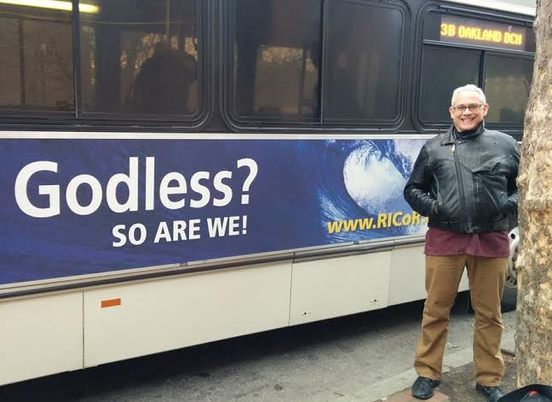
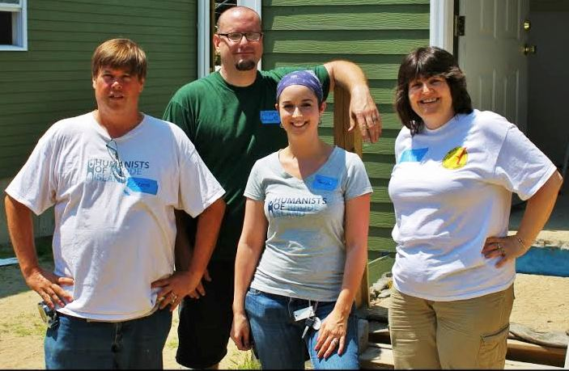
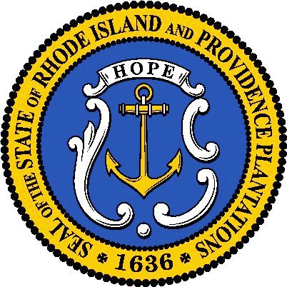
Rhode Island
CoR
August 2016
Sunday | Monday | Tuesday | Wednesday |  | Thursday | Friday | Saturday
 | 1 | 2 | 3 |  | 4 | 5 | 6
7 | 8 | 9 | 10 |  | 11 | 12  International Youth Day | 13
14 | 15 | 16 | 17 |  | 18 | 19  World Humanitarian Day | 20
21 | 22 | 23 | 24 |  | 25 | 26 | 27
28 | 29 | 30 | 31

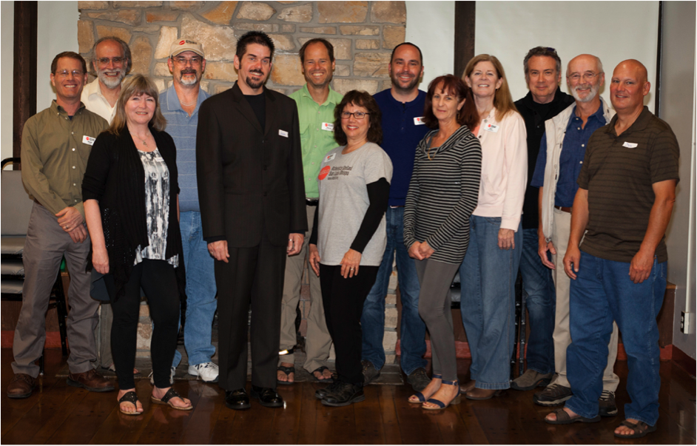
Central Coast CoR (CA)
September 2016
Sunday | Monday | Tuesday | Wednesday |  | Thursday | Friday | Saturday
 |  |  |  |  | 1 | 2 | 3
4 | 5  Labor Day | 6 | 7 |  | 8  International Literacy Day | 9 | 10
11 | 12 | 13 | 14 |  | 15 | 16 | 17
18 | 19 | 20 | 21  International Day of Peace |  | 22 | 23 | 24  Banned Book Week
25 | 26 | 27 | 28 |  | 29 | 30

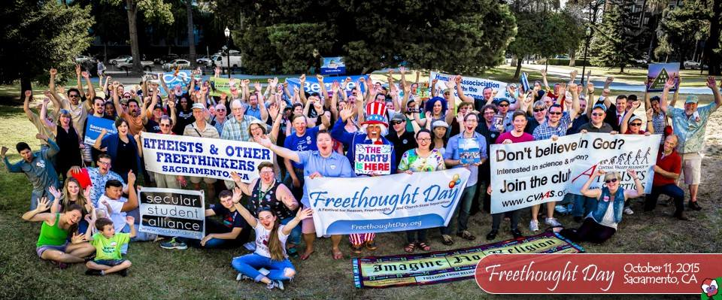
Sacramento Freethought Day 2015
October 2016 |  |  |  | National Disability Awareness Month
Sunday | Monday | Tuesday | Wednesday |  | Thursday | Friday | Saturday
 |  |  |  |  |  |  | 1
2 | 3 | 4 | 5 |  | 6 | 7  FFRF Conference  7--9 Pittsburg | 8
9 | 10  Columbus Day | 11 | 12  Freethought Day |  | 13 | 14 | 15  World Teachers Day
16  Sacramento Freethought Day | 17 | 18 | 19 |  | 20 | 21 | 22
23 | 24  United Nations Day | 25 | 26 |  | 27 | 28 | 29
30 | 31  Halloween

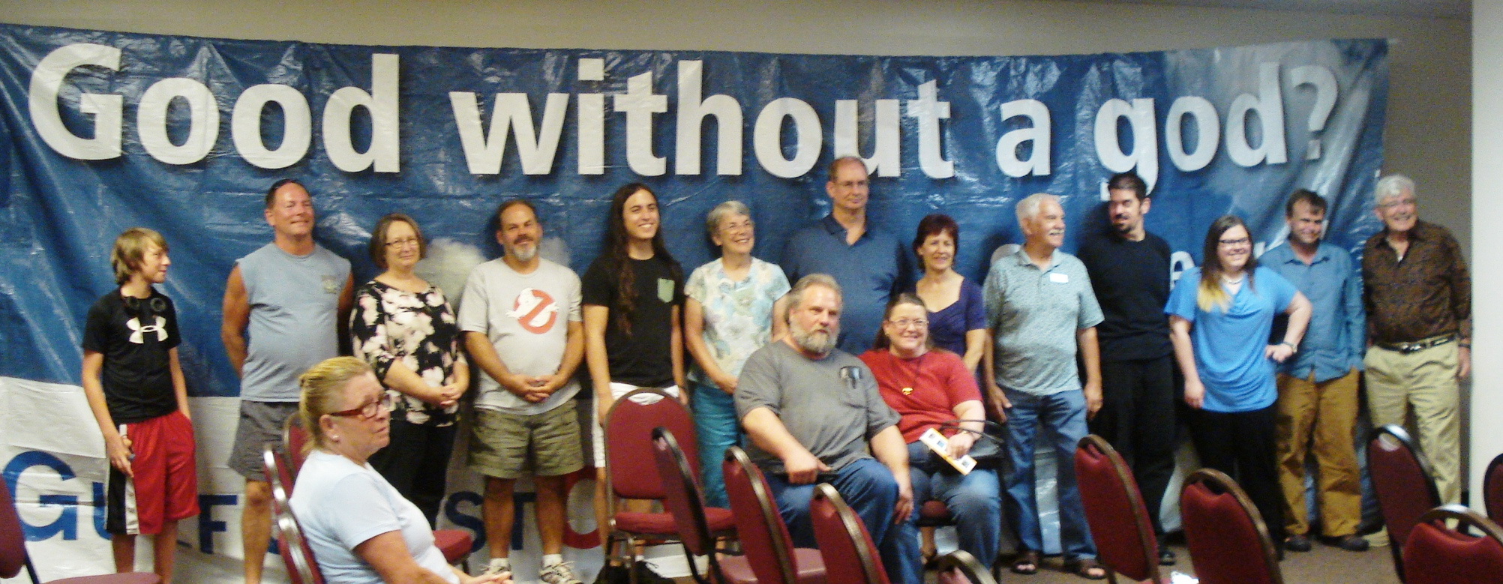
Gulf Coast CoR
November 2016 |  |  |  | Native American Heritage Month
Sunday | Monday | Tuesday | Wednesday |  | Thursday | Friday | Saturday
 |  | 1 | 2 |  | 3 | 4 | 5
6 | 7 | 8  Election Day | 9 |  | 10 | 11  Skepticon 9  11-13 Missouri  Veterans Day | 12
13 | 14  Education Week | 15 | 16 |  | 17  World Philosophy Day | 18 | 19
20 | 21 | 22 | 23 |  | 24  Thanksgiving | 25 | 26
27 | 28 | 29 | 30

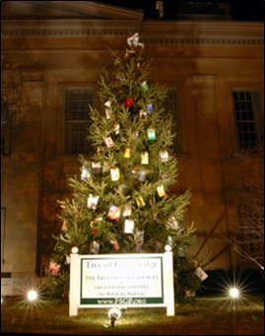
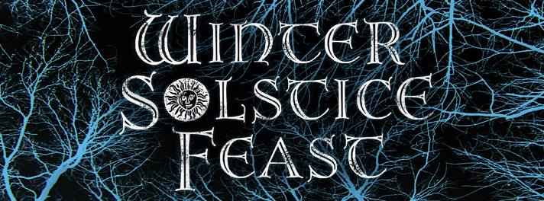
Tree
of
Knowledge
Philly CoR
December 2016
Sunday | Monday | Tuesday | Wednesday |  | Thursday | Friday | Saturday
 |  |  |  |  | 1  World Aids Day | 2 | 3
4 | 5 | 6 | 7 |  | 8 | 9 | 10  Human Rights Day
11 | 12 | 13 | 14 |  | 15 | 16 | 17
18 | 19 | 20 | 21  Winter Solstice |  | 22 | 23  Human Light Celebration | 24
25  Christmas Day | 26  Christmas Day  (observed) | 27 | 28 |  | 29 | 30 | 31

